SQLLAB Assignment Day7 Functions and Cursors

01_Aaditya Sudhir Joshi

1. Create a function for returning and displaying count of employees from employees table whose salary > 30000

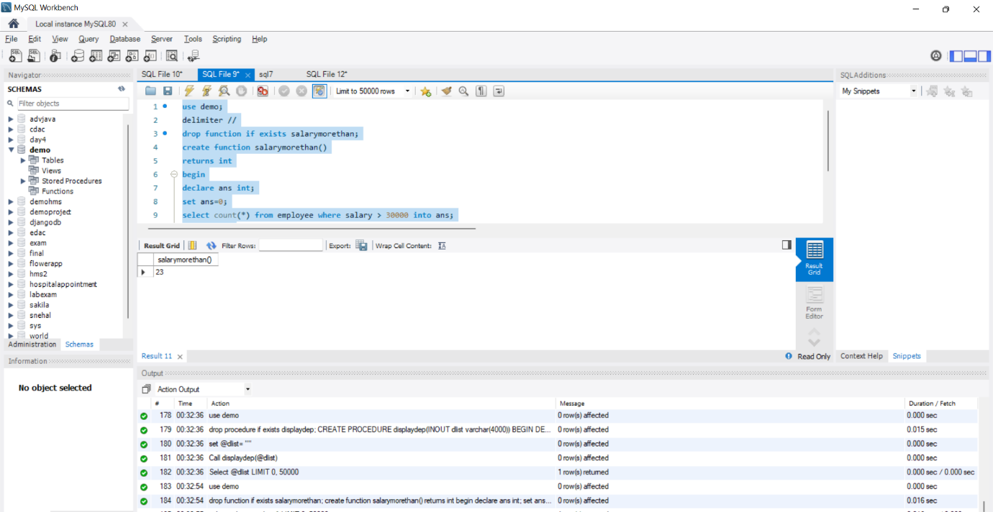

2. Create a function for displaying department name and location of all departments in the form of a string output using cursor. Department name and its location separated by ‘-‘ (hyphen) and each pair separated by ‘|’

Eg : IT-Kochi|Sales-Mumbai

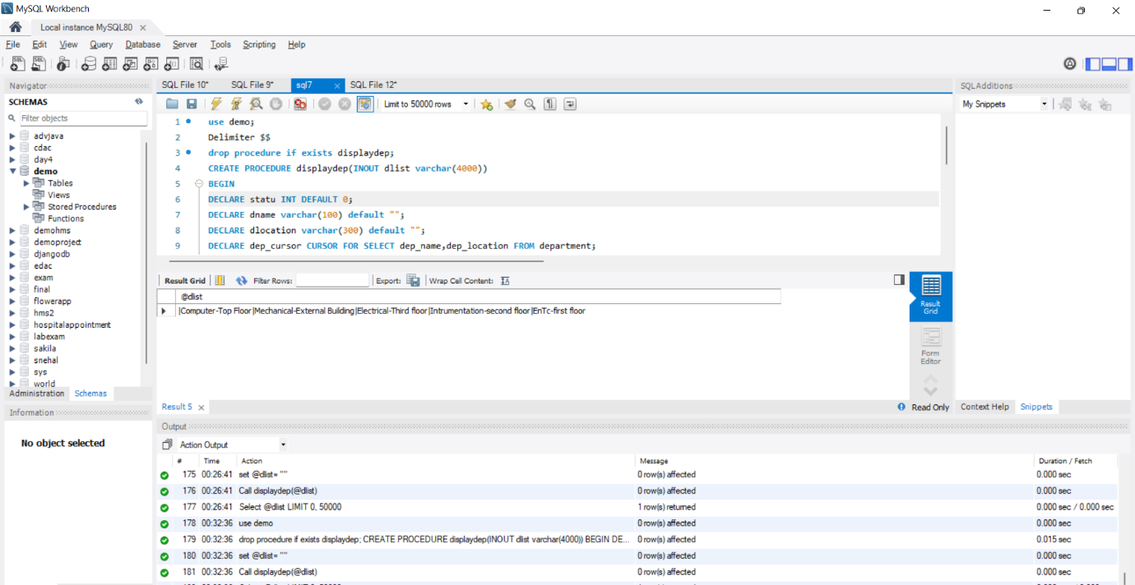

3. Alter your customer table by adding a new column/field named

credit with any numeric data type int/float/double use any of

these.

a) Update your customer table for each row for this new

column credit with some values; Assign values in the

range from 10000 to 5000

b) Create a function to check the credit of each customer by

passing customerid and assign a level using cursor

If credit &gt;= 35000 then

Level=”Platinum”

If credit &gt;= 25000 and &lt;35000

Level=”Gold”

If credit &gt;= 15000 and &lt;25000

Level=”silver”

Else

Level=”Regular”’

The function should return the Level of the customer

along with name

Eg: the sample output/return from function to be as

below

The credit level of Ana is Gold

Answer:-

use demo;

drop function if exists customerupdate;

DELIMITER $$

CREATE FUNCTION customerupdate(custname varchar(100),credit int)

RETURNS VARCHAR(200)

DETERMINISTIC

BEGIN

DECLARE custom VARCHAR(200);

IF credit > 35000 THEN

SET custom = 'PLATINUM';

ELSEIF (credit >= 25000 AND

credit <= 35000) THEN

SET custom = 'GOLD';

ELSEIF credit < 25000 THEN

SET custom = 'SILVER';

END IF;

SET custom = concat('The credit level of ' , custname,' is ',custom);

-- return the customer level

RETURN (custom);

END$$

DELIMITER ;

SELECT

custid,

customerupdate(custname,credit)

FROM

customer

ORDER BY

custname;

